**附件2：**

**腾讯视频会议APP下载方式：手机应用商店搜索“腾讯会议”后下载或登录**<https://cloud.tencent.com/act/event/tencentmeeting_free?fromSource=gwzcw.3213548.3213548.3213548&utm_medium=cpc&utm_id=gwzcw.3213548.3213548.3213548>**进行下载。**

**腾讯会议APP标识：**

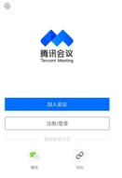

**注：**会议主持人为答辩秘书